**­­­Expressionism in Australia**

German Expressionism had a major influence on radical Australian modernism, in particular, on the development of social realism and work by the more libertarian artists associated with the magazine *Angry Penguins*. Expressionism facilitated critical engagement with a conservative and insular culture that, by the 1930s, was still largely dominated by the ‘plein air’ naturalism of the Heidelberg School. Modernists like Josl Bergner (b.1920), Danila Vassilieff (1897-1958), Albert Tucker (1914-99), Joy Hester (1920-1960), John Perceval (1923-2000), Arthur Boyd (1920-99) and others used expressionist styles to depict the human figure under some form of pressure, as an index of the current social condition. They played with the human form through distortion or sketchy reduction. Similar liberties taken with spatial relations and non-naturalistic colour, along with loose, spontaneous brushwork conveyed an intensity of mood: a mood increasingly characterised by anxiety with the coming of the Second World War. Willis observes that, by the late 1930s, Expressionism had become a transportable, international philosophy and a practical style of protest. It was the chosen style of the exile, the foreigner, the displaced person, withits undercurrent of spirituality, a yearning for roots or homeland.

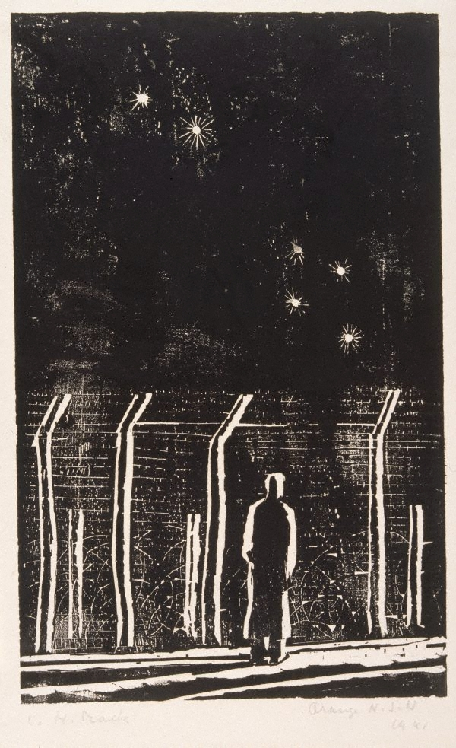

Ludwig Hirschfeld-Mack, *Desolation, Internment camp, Orange, NSW*, 1941, woodcut, printed in black ink on thin ivory wove paper 21.6 x 13.5 cm blockmark; 33.6 x 21.0 cm sheet. Collection of Art Gallery of NSW, http://www.artgallery.nsw.gov.au/collection/works/DA9.1970/

European refugees were beginning to affect cultural life by the mid 1930s. The Jewish immigrant Sali Herman (1898-1993) turned up at Melbourne’s George Bell School in 1937 with highly charged, expressionist canvasses. Bergner also arrived that year with fresh memories of depression hardship in the Warsaw ghetto, and expressed a personal identification with the despair and marginalisation of Indigenous Australians in his 1941 painting *Aboriginals in Fitzroy*. The Russian adventurer Danila Vassilieff was no stranger to nomadic poverty by the time he arrived in Australia in 1935, and the ex-Bauhaus artist Ludwig Hirschfeld-Mack (1893-1965), a refugee aboard the infamous H.N.T. Dunera, was introduced to Australian art whilst interred as an enemy alien. Isolation, loneliness and the hopeful attempt to find one’s bearings under an unfamiliar southern constellation are expressed in his small woodcut print *Desolation,* *Internship Camp, Orange* (1941). Expressionist techniques helped artists to register a subjective response to a social situation and start a conversation through opening up aesthetic possibilities. To make sense of these works, the viewer had to take time in looking. Perceptual and intellectual effort was needed to meet these artworks halfway, and the viewer became conscious of the fact that they were seeing things differently. These were more than just pretty pictures – they were visual propositions for a change of consciousness – a prerequisite for social change itself.

**References and Further Reading:**

Stephen, A; McNamara, A. and Goad, P (eds), (2006). *Modernism & Australia: Documents on Art, Design and Architecture 1917-1967*. Melbourne: Miegunyah Press (Part 11: 1938-1949 contains a useful compilation of documents from the period)

Eagle, M. (1989), *Australian Modern Painting Between the Wars 1914-1939*, Sydney: Bay Books. (A well-illustrated, social history of inter-war art movements).

Willis, A. (1993) ‘Art of Assimilation’, in *Illusions of Identity: The Art of Nation*, Sydney: Hale & Iremonger (A thoughtful appraisal of expressionism’s ‘portable philosophy’ as a destabilizing force in Australia’s national identity).

For further individual artist biographical information, refer to the *Design and Art Australia Online* http://www.daao.org.au